Market Madness Game

Last August, the University of Chicago Magazine asked Allen Sanderson to create an NCAA-like tournament with four regions, brackets and seeded teams. But instead of a field comprised of basketball squads, this one - dubbed "Market Madness" - was to contain 16 competitive factors contributing to the global financial meltdown of the last two years. (Their only constraint was that The Chicago School of Economics had to be a competitor.)
To get started, each "team" got a name and a brief description as to why it was included in the tourney. Chicago Alumni and friends then participated in on-line voting in Autumn 2009 to select their personal or preferred outcomes for each of the match-ups, which moved from the "Sweet 16" to the "Elite 8," and then to the "Final Four" and the ultimate winner (that is, the person or thing most responsible for the financial crisis and recession).
With permission from the University of Chicago Magazine, the AEA was pleased to offer its members a chance to fill out their own brackets and submit their entries and pick an ultimate "champion." Below you will find the four named regions, the four competitors in each region, and a brief introduction to each team.

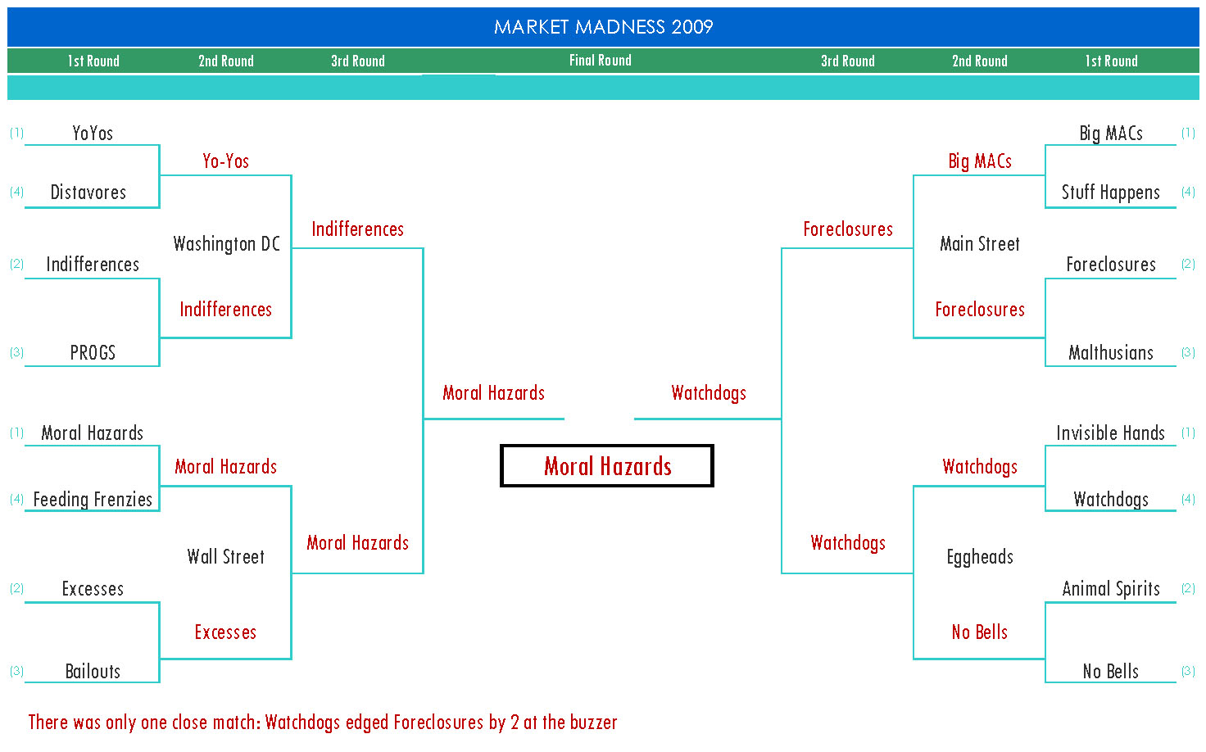
Region I: Washington DC
Always a perennial powerhouse area, this year the bracket's competitors are all worthy of consideration to make it to the Final Four.
The top seed, the Federal Reserve System squad, the "Yo-Yos", co-coached by Greenspan and Bernanke, pursued up-and-down interest rate strategies, aided and abetted bailouts and bankruptcies, and engaged in accommodating monetary policy actions that now threaten to convert a recession into inflation.
The Bush administration team, the Indifferences, cut taxes like (and for) Republicans, spent money like Democrats, looked the other way on regulation, and, with sheer disengagement and an anything-goes attitude, forgot to mind the store and guard the piggy bank from the bandits.
Never wanting to let a crisis go to waste, the "PROGS" (Pelosi, Reid, Obama, Geithner, Summers) team relied on stimulus spending and fiscal sleight of hand, produced massive, unsustainable deficits, and stirred up market and individual anxieties over the next tax and regulatory shoes to drop. But can they juggle and dribble at the same time?
"The Distavores", the only foreign entry, looked beyond the beltway to wreak havoc with too many international balls in the air: terrorism and wars; trade policies and imbalances; meltdowns in Europe; oil and environmental concerns; China; and the slightly insane nuclear bad guys. Or was this crisis strictly Made in the U.S.A.?

Region II: Wall Street
A lot to like in this region, all from Gordon Gekko's playbook: the bonuses, $2,500 Yankee Stadium seats, cool new words, and North Carolina inmate # 61707-054.
The Financial Sector's "Moral Hazards" team is outstanding. They froze credit markets (except for themselves - the twerps got TARPs) and forced us to Google securitization and credit default swaps. You do need a scorecard to tell the players: AIG, Bear Stearns, Lehman Brothers, JPMorgan Chase, Bank of America, Merrill Lynch. Can you say "risk management"?
"The Excesses" from Wall Street, feature executive compensation schemes, Madoff mentalities, and enough hide-the-fraud techniques and three-card-Monte dexterity to keep intellectually and morally-challenged boards and regulators at bay. They could make even an ardent capitalist blush.
What could be more American than apple pie, the Cubs choking, and a Toyota? Detroit - auto firms and their unions - have largely on their own dug an enormous hole for themselves Then these same "Bailouts" want the rest of us to climb in with them. No more cash for these clunkers. What's good for General Motors is . . . probably never a good idea.
Give us your tired, your poor, your huddled masses, as well as your unemployed debtors, and we'll feature them on Page 1 and the 10 O'Clock News. Consumer - and business - confidence is an important gauge of economic activity, and "The Feeding Frenzies" media team is unrelenting in its self-interested pursuit of bad news.

Region III: Main Street
Maybe Pogo was on to something with his well-known line: "We have met the enemy and he is us." There's plenty of fault to go around for everyone in this third bracket.
Addicted to credit cards and donuts, the "Big MACs" - Middle American Consumers - feature a spreading offense. They believe in free lunches, the debt-relief fairy, that saving money is "so 20th century," malls are an excellent form of exercise, and that what Brad Pitt thinks is actually important.
In pre-season rankings the "Foreclosures" were a favorite to win it all. The real estate market, "egged on" by ill-advised public policies that encouraged and subsidized home ownership (think subprime mortgages, zero down payments, low interest rates, and tax breaks), provided incentives and arbitrage opportunities for folks to buy and/or flip large houses.
Satchel Paige warned us not to look back (because something might be gaining on us), but not looking forward is also unwise. In this case, changing demographics, brought on by the aging of Baby Boomers and immigration patterns and policies has affected (and will continue to affect) health care costs and Social Security commitments for the "Malthusians" starting-five.
"Stuff Happens" is a reliable team to pencil in. Business cycles are normal, recurring events in any economic system. We've experienced stock-market and dot-com bubbles; now it's housing. We had downturns in 1990-91 and 2000-01; we were about due for another one. As the first-do-no-harm doctor would advise, take two aspirin, drink plenty of liquids, and get some rest.

Region IV: The Eggheads
How can you tell that macro economists have a sense of humor? They use decimal points. This regional foursome is loaded with talent and egos.
The "Invisible Hands" from the Chicago School of Economics, featuring the laissez-faire abandon of Milton Friedman, the efficient-market mantra of Eugene Fama, and the rational expectations of Robert Lucas, almost take pride in being cast in the role of spoiler - or spoiled sport - in this tourney.
Strong on psychology, 'Animal Spirits' irrationality, and herd-like behavior, these "behavioral boys" boast a starting line-up of Akerlof, Frank, Krugman, Shiller and Stiglitz. But can these "HurriKeynes" stand up against the rational, calculating play of the Chicago Boys?
Armed with models and data that have predicted 22 of the last 5 recessions, why didn't the profession -- academic and real-world, private and public macroeconomists -- alert us to, and provide remedies for, this crisis? The make-up of the "No Bells" team makes one appreciate the appeal of magic and pine for the accuracy of weather forecasts.
"The Watchdogs", the credit-rating experts and their performance handlers (where Moody's is supposed to be an agency not a feeling, and SEC does not stand for Southeastern Conference) always bring their AAA game. But can they hold their slice-and-dice tactics in check, learn other letters of the alphabet, and remember that being paid by the very people whose bonds they are rating just might constitute a conflict of interest?

